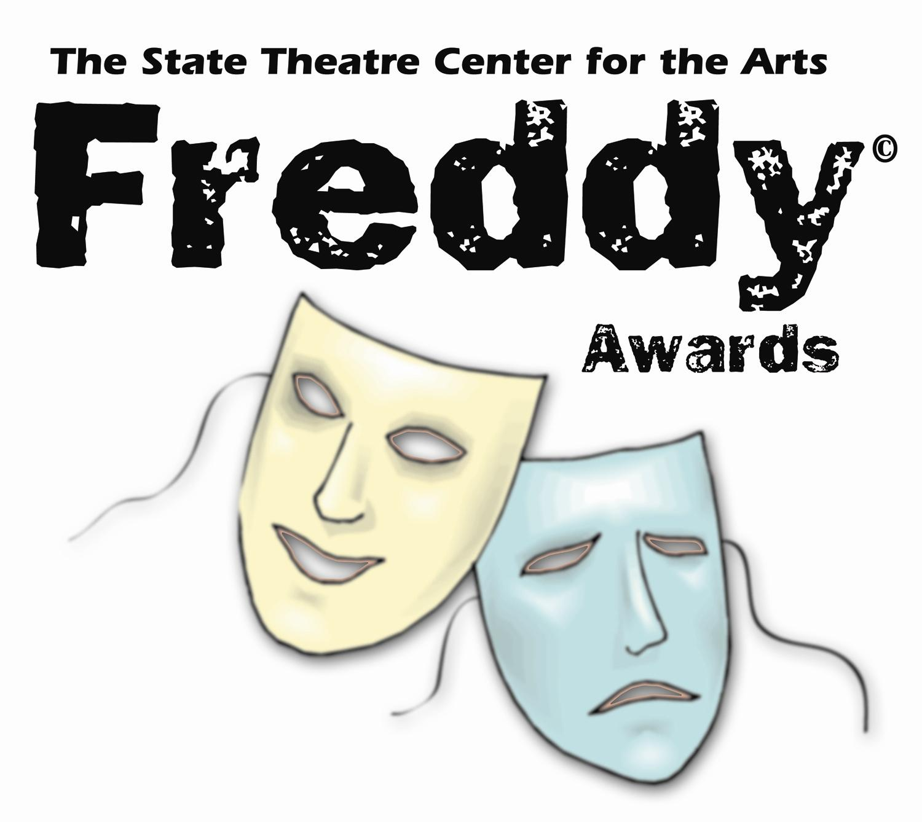
Fillifill-in blan

To recognize and reward exceptional accomplishments in the production and performance of musical theatre in local high schools

2022 FREDDY© AWARDS EVALUATOR APPLICATION

Please provide the following information (you may attach a resume)

Name:

Address: City/State/Zip code:

Home Phone: Work/Daytime Phone:

Cell Phone: E-Mail Address:

Why would you like to be a FREDDY© Awards evaluator?

Please list your theater experiences and/or qualifications to be an evaluator (including teaching, performance, production, workshops, volunteer, patron of the arts, Board of Directors, committees, etc.):

Please list any affiliation with Lehigh Valley, PA and/or Warren County, NJ school districts (alumnus, relationship to students, teacher/coach, musical director, school administrators, etc.) Please include name(s) of family member(s) attending a FREDDY© Awards participating school along with age, current grade and graduating class:

Do you have any family members directly involved with a FREDDY© Awards production or participating school? ☐ NO ☐YES
If YES, please explain:
Evaluators MUST be available for an Orientation/Show Assignments Meeting on Tuesday, January 18, 2021 at 6:30pm, and must be available to judge performances at local high schools between February and May, 2022 (schedule to be determined) and for final voting sessions on Tuesday, May 17, 2022 at 6:30pm. We are also looking to hold an Evaluator Training Session on Wednesday, November 10th, 2020 from 6pm to 8pm.
***PLEASE NOTE Evaluator Requirements: All evaluators will be required to attend a minimum of 14 shows per season.
- In your role as an official evaluator you will need to attend a minimum of 5 shows during the season.
- In your role as an unofficial evaluator you will need to attend a minimum of 9 shows during the season.
- We highly recommend, for the sake of the process and fairness to schools involved, evaluators see more than the 14 show minimum to be better prepared for the final voting session.
Please list any schedule conflicts that you are aware of at this time:

Please submit application to Jamie Balliet, FREDDY© Coordinator – jballiet@statetheatre.org

Or mail to: State Theatre FREDDY© Awards
453 Northampton Street
Easton, PA 18042

The integrity of The FREDDY© Awards program is precious. It is the pride and privilege of the State Theatre to showcase students from any and all high schools that present a musical show from Lehigh, Northampton, and Warren Counties. A key element to the program’s success is the discretion and the unbiased opinions of its evaluators.

