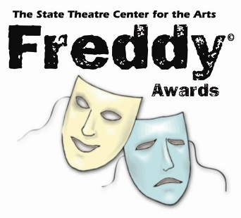

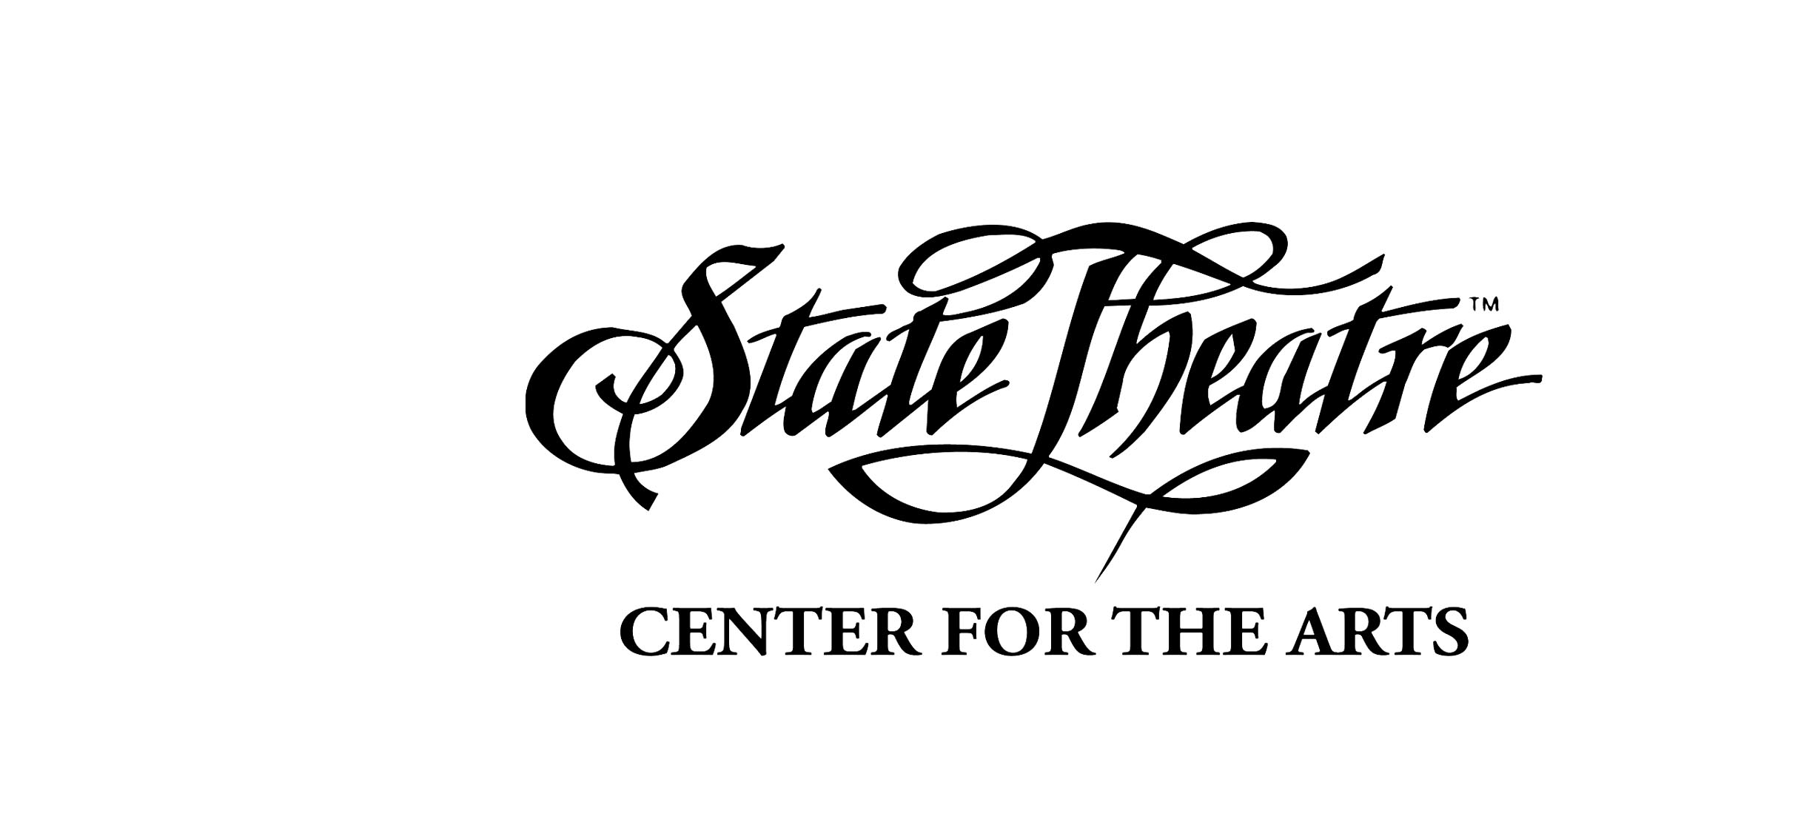

# To recognize and reward exceptional accomplishments in the production and performance of musical theatre in local high schools

## 2018 STUDENT ACHIEVEMENT AWARD

## SELF-NOMINATION APPLICATION

***For a student choreographer, stage manager, company manager, director, assistant director, musical director or chorus member***

[Lehighvalleylive.com and The Express-Times](http://www.lehighvalleylive.com/), sponsors of the 2018 FREDDY© Awards, will offer a **$1,500 scholarship** to the student recipient of the 2018 Student Achievement Award, which is announced at the FREDDY© Awards Ceremony. This is a self-nominating scholarship, and is available to students who participate in their school’s musical theater program in a backstage capacity, such as a stage manager, stage crew, scenic design, student/assistant directors and choreographers Students nominees must complete this self-nomination form. Additionally, this nomination form must be accompanied by the TEACHER RECOMMENDATION FORM.

STUDENT NAME: Click or tap here to enter text.

SCHOOL NAME: Click or tap here to enter text.

NAME OF MUSICAL: Click or tap here to enter text.

CONTACT PHONE NUMBER: Click or tap here to enter text.

E-MAIL ADDRESS: Click or tap here to enter text.

Please briefly answer the following questions:

In what capacity do you serve for your school’s musical theater program?

Click or tap here to enter text.

Tell us about your favorite part of this role, and how you have helped to improve quality of your production in this capacity.

Click or tap here to enter text.

In addition to musical theatre, what other activities or extra-curricular activities are you involved in?

Click or tap here to enter text.

What are your college and/or career plans for after high school?

Click or tap here to enter text.

Tell us a little more about yourself! What are your strengths and attributes that make you the best candidate for the Student Achievement Award.

Click or tap here to enter text.

**PLEASE INCLUDE THE FOLLOWING WITH THE APPLICATION:**

* **Teacher Recommendation Form**: In 500 words or less, please have your theatre director, a teacher or counselor provide a brief recommendation based on their experience with you, along with their e-mail address and phone number.
* Please supply any support materials you feel will be helpful in the review of this application

Applications must be received by the **State Theatre** no later than **4:00 PM on April 30, 2018.**

State Theatre • Frank Kutch • 453 Northampton Street • Easton, PA 18042 • 610-258-7766 • www.freddyawards.org